**/describe**

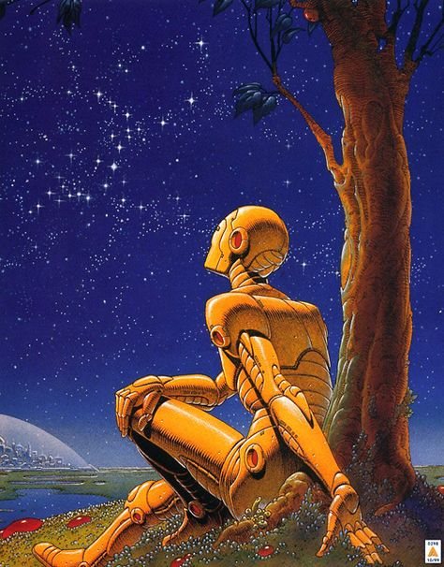

1️⃣ the yellow robot on a branch, looking up to the stars, in the style of richly detailed genre paintings, neo-geo, romanticized views, i can't believe how beautiful this is, colorful moebius, golden age illustrations, serenity and calm --ar 59:75

2️⃣ an image of an android sitting under a tree and watching the sky, in the style of golden age illustrations, futuristic robots, orange and gold, romanticized realism, ps1 graphics, i can't believe how beautiful this is, illuminated visions --ar 59:75

3️⃣ an illustration of an orange robot sitting with leaves under the sky, in the style of ted nasmith, contemplative scenes, golden age illustrations, pensive poses, nocturne, jean giraud, romanticized views --ar 59:75

4️⃣ an illustration showing an orange robot sitting on the ground and looking, in the style of michael whelan, classical romanticism, jean giraud, dark sky-blue and gold, ted nasmith, i can't believe how beautiful this is, pensive poses --ar 59:75

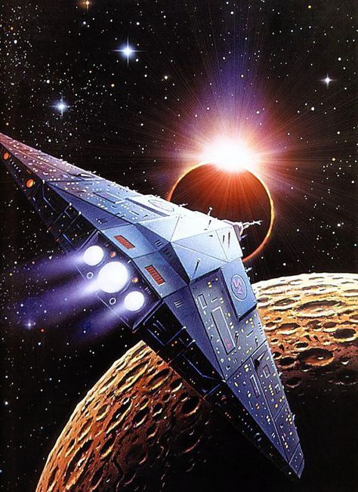

1️⃣ a spaceship in space with sun and other planets surrounding it, in the style of sharp and angular, 1980s, realistic marine paintings, cartelcore, nabis, elaborate --ar 59:81

2️⃣ a sci fi painting of a flying spaceship, in the style of neogeo, kushan empire, sharp and angular, solarizing master, sharp attention to detail, 1970–present, photo taken with provia --ar 59:81

3️⃣ an original poster for a spaceship over the sun, in the style of larry elmore, yasuhiro nightow, outrun, modular, saturno butto, genre painting, sharp attention to detail --ar 59:81

4️⃣ a spaceship with spacecraft in space, in the style of larry elmore, sharp and angular, genre defying, outrun, symbolic nabis, saturno butto --ar 59:81

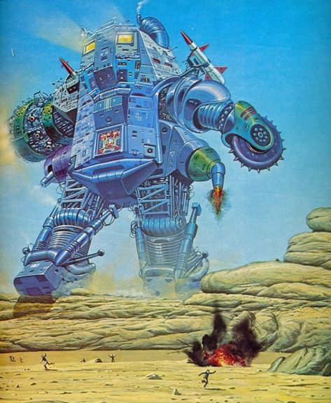

1️⃣ the cover of a scifi novel featuring a giant robot, in the style of gary larson, edward hersey, konica auto s3, vasily vereshchagin, desertpunk, ultrafine detail, steelpunk --ar 59:72

2️⃣ a blue robot surrounded by a fire, in the style of frank mccarthy, ed roth, angus mckie, modular, desertwave, illustrative, steel --ar 59:72

3️⃣ an art book about the game, one of the images was painted by john adair, in the style of mechanized precision, spacesolarpunk, adventure pulp, salvagepunk, desertwave, dark gray and sky-blue, poster art --ar 59:72

4️⃣ requiem for a future universe cover art, 1979, in the style of mechanized precision, realistic detail, salvagepunk, the blue rider, desertwave, historical illustration, konica big mini --ar 59:72

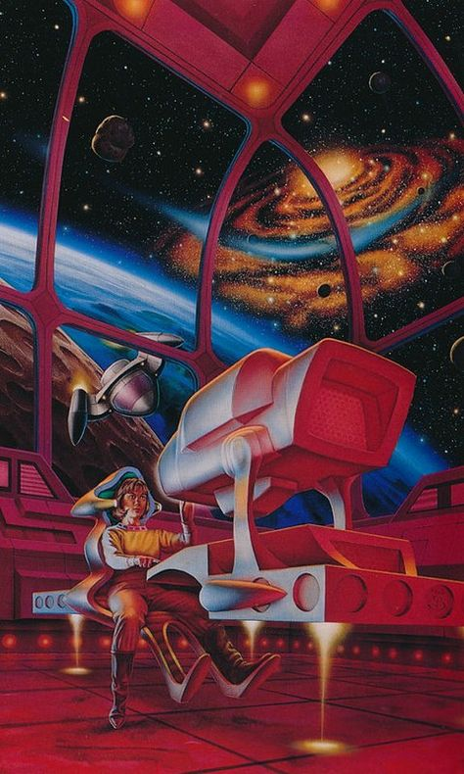

1️⃣ a sci fi space painting with a red chair and red planet, in the style of neo-geo, fantastical machines, 1980s, airbrush art, romanticized views, youthful protagonists, blown-off-roof perspective --ar 59:98

2️⃣ an image of a space station with a man inside, in the style of colorful moebius, white and crimson, hard edge painting, neo-geo, airbrush art, romanticized views, die brücke --ar 59:98

3️⃣ a painting of a space man looking out, in the style of noriyoshi ohrai, outrun, larry elmore, playful machines, thomas hart benton, konica auto s3, caninecore --ar 59:98

4️⃣ a rocket, flying into space, with the rocket sitting inside, in the style of clyde caldwell, mind-bending murals, konica auto s3, isometric, larry elmore, john pitre, white and crimson --ar 59:98

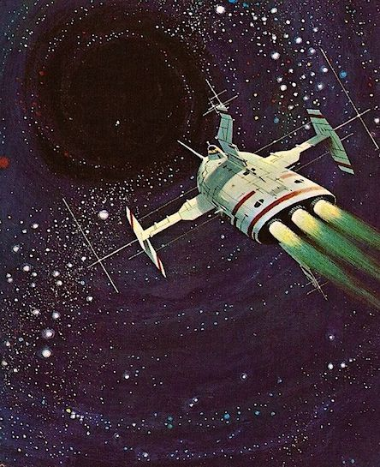

1️⃣ a spaceship with a space laser is flying over an oval space, in the style of post-war art, angura kei, canon 7, 1960s, action painter, distinctive noses, flickr --ar 55:68

2️⃣ the alien space craft flying over the'starship', in the style of hal foster, range murata, ed valigursky, 1960s, swirling vortexes, canon f-1, genre painting --ar 55:68

3️⃣ a spaceship flying in a deep space, in the style of john philip falter, swirling vortexes, range murata, dynamic and action-packed --ar 55:68

4️⃣ an illustration of spaceships and spaceships flying through the space, in the style of 1960s, adventure pulp, realist detail, canon 7, dark white and green, flickr, ferrania p30 --ar 55:68

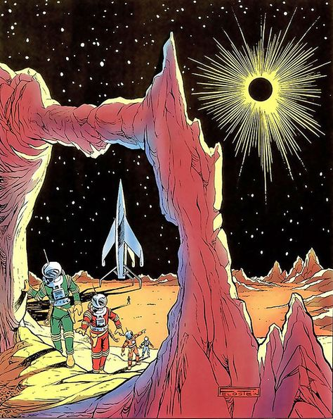

1️⃣ comic book of an astronaut walking through a cave in a desert, in the style of solarizing master, elaborate spacecrafts, post-'70s ego generation, mysterious figures, trompe-l'œil illusionistic detail, expansive skies, solarpunk --ar 59:74

2️⃣ the comic covers of the saturn stories if you had a timer to read, in the style of otherworldly landscapes, earl norem, elaborate spacecrafts, cartoon mis-en-scene, pictorial space, peter bagge, manga-influenced --ar 59:74

3️⃣ space flight comic, in the style of colorful moebius, frank thorne, earthworks, solarizing master, celestial, adventurecore, iconic --ar 59:74

4️⃣ the cover for the comic book, in the style of otherworldly scenes, elaborate spacecrafts --ar 59:74

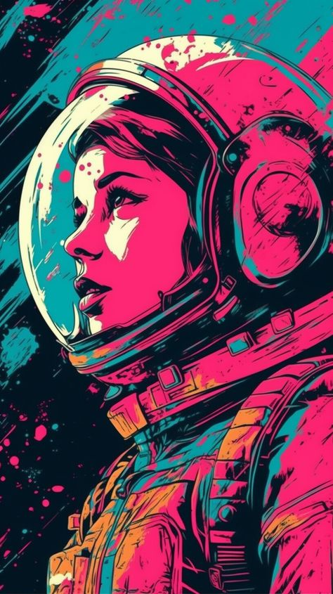

1️⃣ the pink astronaut girl, in the style of martin ansin, psychedelic color schemes, imax, rone, pop-culture-infused, poster art, close up --ar 59:105

2️⃣ a bright, colorful lady in an astronaut's spacesuit, in the style of martin ansin, dark pink and dark cyan, imax, miwa komatsu, nostalgic mood, pink and cyan, alan bean --ar 59:105

3️⃣ a bright space girl that's astronaut in space, in the style of pop art-inspired visuals, dark pink and dark cyan, imax, controlled palette, pop-culture-infused, dye-transfer, i can't believe how beautiful this is --ar 59:105

4️⃣ astronaut girl in pink spacesuit isolated on black, in the style of pop art color palette, urban-inspired murals, #film, animated gifs, i can't believe how beautiful this is, poster art --ar 59:105

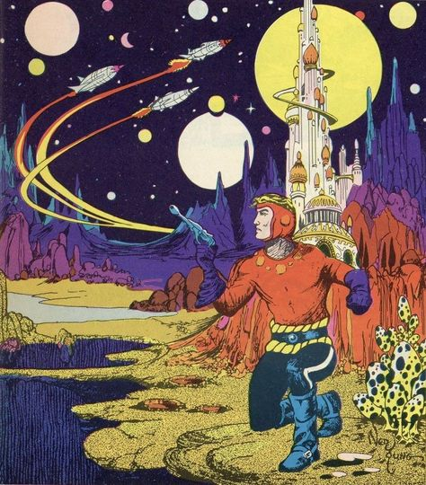

1️⃣ a vintage comic book cover featuring a man standing in front of a castle, in the style of cosmic, datamosh, colorful animation stills, colorful moebius, trompe-l'œil illusionistic detail, action-packed cartoons, flickr --ar 59:67

2️⃣ comic strip cover image, by neil godard, with star and man, in the style of elaborate spacecrafts, ivan bilibin, steve ditko, fantasy-based, jim lee, comic book-influenced, hurufiyya --ar 59:67

3️⃣ the cover of doodles and ladles from the new marvel london comic, in the style of jean giraud, cosmic landscape, albrecht dürer, pictorial space, ted nasmith, trompe-l'œil illusionistic detail, soviet --ar 59:67

4️⃣ the cover to d w w vol 1, in the style of colorful moebius, pictorial space, adventure pulp, 15th century, ironical, starpunk, mono-ha --ar 59:67

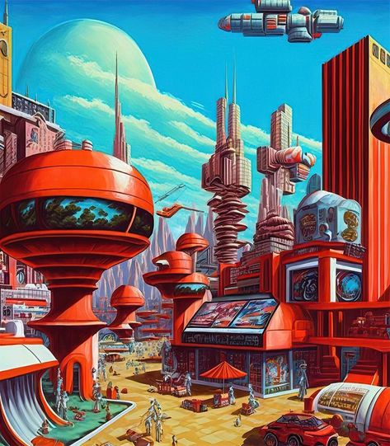

1️⃣ an art painting of the futuristic city, in the style of sky-blue and red, richly detailed genre paintings, cartelcore, cartoon realism, precisionist lines, 1970–present, bulbous --ar 59:67

2️⃣ a painting of a futuristic city with red cars and an airplane, in the style of richly detailed genre paintings, heistcore, light red and turquoise, cartelcore, mind-bending murals, neo-geo, depiction of everyday life --ar 59:67

3️⃣ futuristic city with futuristic cityscape, in the style of patrick woodroffe, light red and turquoise, meticulous realism, katsuhiro otomo, cassius marcellus coolidge, richly detailed genre paintings, domesticity --ar 59:67

4️⃣ ft by person sci fi art work, in the style of patrick woodroffe, vibrant cityscapes, light red and azure, elaborate spacecrafts, high detail, go nagai, schizowave --ar 59:67

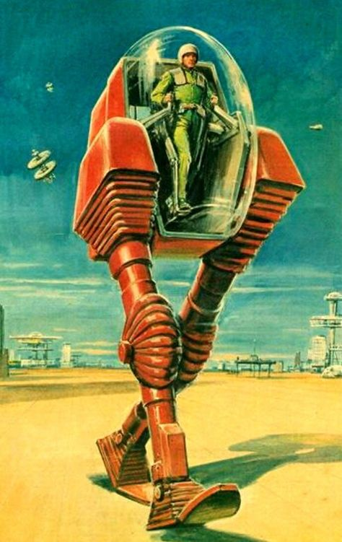

1️⃣ the first image of a robot which will make great art film, in the style of karel thole, action-packed cartoons, chesley bonestell, green and crimson, kurt wenner, distinctive noses, cubo-futurism --ar 59:93

2️⃣ the art of science fiction, science fiction art, science books, space, science fiction robots, sci fi covers, sci fi cover art, in the style of art frahm, red and cyan, trompe-l'œil illusionistic detail, don bergland, full body, transportcore, argus c3 --ar 59:93

3️⃣ a futuristic robot on the desert floor, in the style of british post-war art, atompunk --ar 59:93

4️⃣ a robot standing on a motorcycle in the desert, in the style of pulp comics, cubo-futurism, soviet, red and emerald, group f/64, movie poster, automatism --ar 59:93

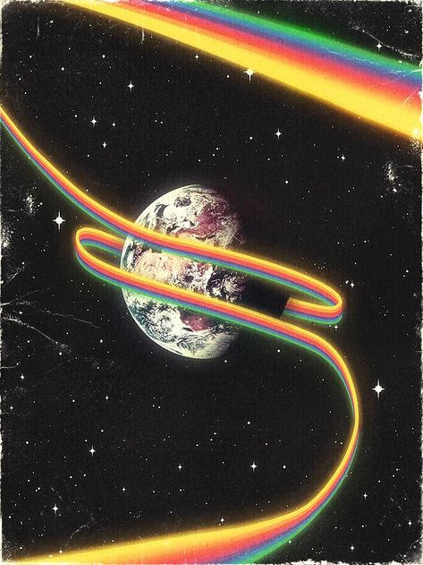

1️⃣ a rainbow spinning around an earth in space, in the style of vintage ephemera, bold and dynamic lines, flickr, fiberpunk, georges gimel, spacesolarpunk, emily carr --ar 59:78

2️⃣ a pink floyd album cover with a rainbow rainbow and planets and stars, in the style of flowing lines, gum bichromate, unconventional use of space, i can't believe how beautiful this is, comic book-influenced, earthcore, erudite --ar 59:78

3️⃣ the world by pink floyd, in the style of interstellar comic book art, painterly lines, 1900–1917, rainbowcore, retro filters, unconventional use of space, james nares --ar 59:78

4️⃣ a poster with a rainbow ribbon in the background, in the style of spacesolarpunk, 1970s, earthcore, mysterious atmosphere, painterly lines, i can't believe how beautiful this is, 1900–1917 --ar 59:78

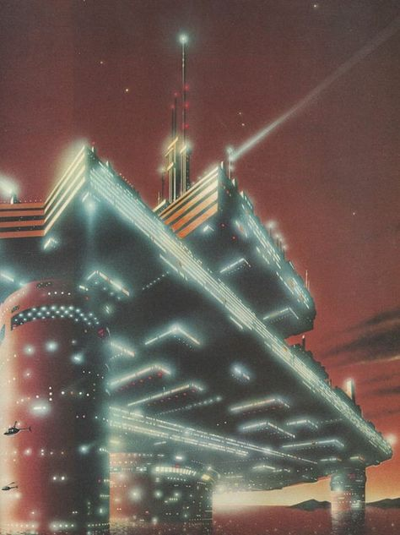

1️⃣ a spaceship floats near an enormous bridge with glowing lights, in the style of soviet avant-garde, art deco sensibilities, group f/64, animecore, realist detail, 1970–present, neo-concrete --ar 59:79

2️⃣ japan tokugawa's space city of steel image, in the style of luminism, cargopunk, secessionist style, soviet avant-garde, subtle lighting, die brücke, floating structures --ar 59:79

3️⃣ an animation of a futuristic structure, with a light bridge, in the style of ed mell, katsuhiro otomo, ivan aivazovsky, lomo lc-a, sovietwave, contax tix, majestic ports --ar 59:79

4️⃣ an image of futuristic architecture at night, in the style of drew struzan, fujishima takeji, transportcore, sovietwave, majestic ports, kazuo koike, dark white and light red --ar 59:79

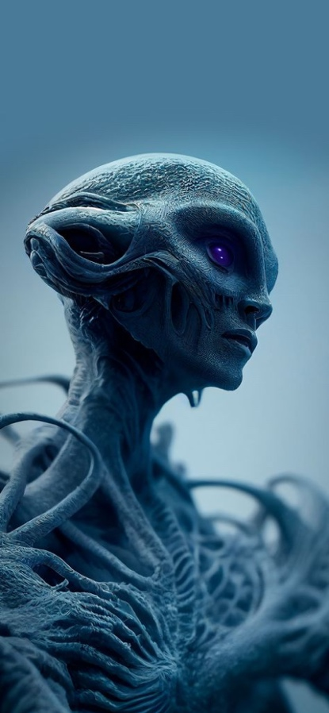

1️⃣ an alien with a blue background, in the style of intricately sculpted, matte painting, light gray and purple, captivating documentary photos, distinct facial features, fantastic creatures, kieron gillen --ar 59:128

2️⃣ an alien is looking skyward, in the style of intricately sculpted, gray and blue, matte painting, exaggerated facial features, violet and blue, marine biology-inspired, voidcore --ar 59:128

3️⃣ humanoid alien by brian moore wallpapers, in the style of dark sky-blue and light violet, hyperrealistic marine life, intricate storytelling, exaggerated facial features, intricately textured, online sculpture, matte photo --ar 59:128

4️⃣ the alien is looking in the direction he could go, in the style of intricately sculpted, violet and blue, eve ventrue, photo-realistic techniques, hybrid creature compositions, expressive facial features, voidcore --ar 59:128

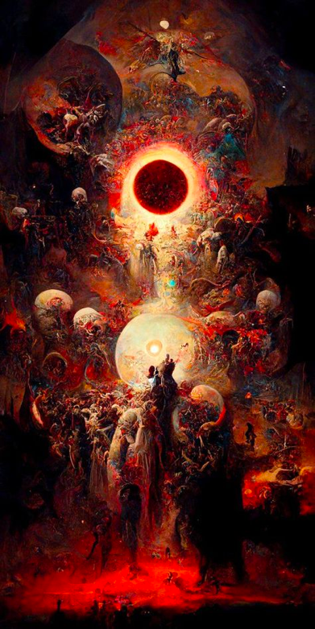

1️⃣ a painting featuring many dark and beautiful images, in the style of precisionism influence, johfra bosschart, james c. christensen, light gold and red, solarization, gustave de smet, devilcore --ar 1:2

2️⃣ a painting is depicting something big in the dark, in the style of jean delville, chaos theory, joachim wtewael, light gold and red, unique yokai illustrations, greg olsen, solarpunk --ar 1:2

3️⃣ brian böckmann dark side of the eye by theo van gogh, in the style of vibrant fantasy landscapes, transcendental art, red and gold, ethereal figures, luminous spheres, organized chaos, detailed skies --ar 1:2

4️⃣ 'the and the flames and the dark fire' by lucian francis ree, in the style of precisionism influence, highly imaginative worlds --ar 1:2

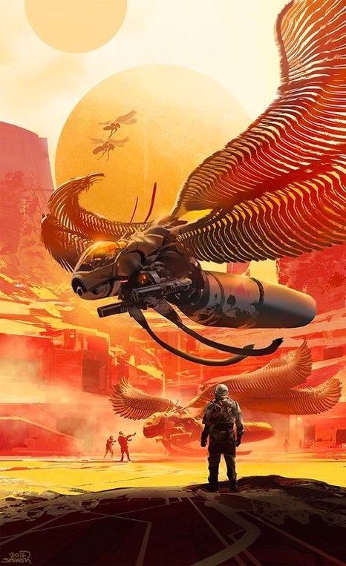

1️⃣ spaceships, humanoid robots, science fiction, sci fi, khanibal lankar, 3d, fantasy worlds,, in the style of gold and amber, life-like avian illustrations, desertpunk, layered imagery with subtle irony, firecore, cobra, post-apocalyptic --ar 59:97

2️⃣ an alien has its wings spread, in the style of sparth, orange and bronze, post-apocalyptic worlds, intricate illustrations, cobra, firecore, long lens --ar 59:97

3️⃣ there is a man standing in front of a brightly colored aircraft, in the style of sparth, intricate and bizarre illustrations, changelingcore, cobra, bronze and amber, martin ansin, solarpunk --ar 59:97

4️⃣ an illustration of several birds in space on a field, in the style of cyberpunk imagery, orange and bronze, precise, detailed architecture paintings, cobra, long lens, made of insects, gold and crimson --ar 59:97

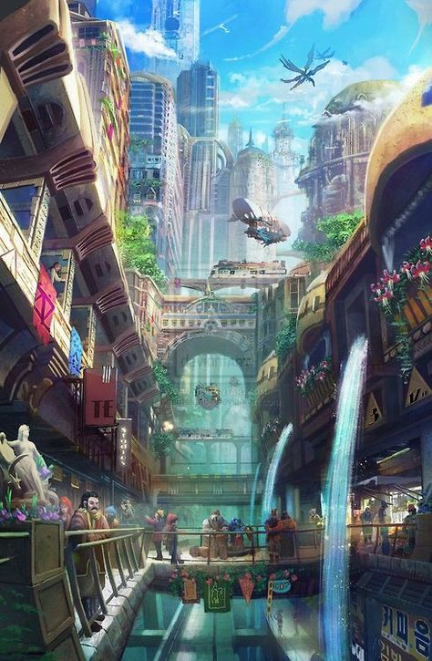

1️⃣ an illustration of a futuristic city with water flows and people walking through it, in the style of mecha anime, art nouveau elegance, i can't believe how beautiful this is, junglecore, colorful street scenes, majestic ports, aerial view --ar 59:90

2️⃣ a scene of a futuristic city with water and buildings, in the style of art nouveau influences, animecore, lively street scenes, gravity-defying landscapes, junglepunk, i can't believe how beautiful this is, quadratura --ar 59:90

3️⃣ an image of a futuristic futuristic city with water and tall buildings, in the style of tatiana suarez, gaston bussière, akihiko yoshida, colorful street scenes, junglepunk, mecha anime, passage --ar 59:90

4️⃣ an abstract illustration of futuristic city life, in the style of daniel f. gerhartz, whimsical anime, edogawa ranpo, passage, detailed world-building, junglecore, richard doyle --ar 59:90

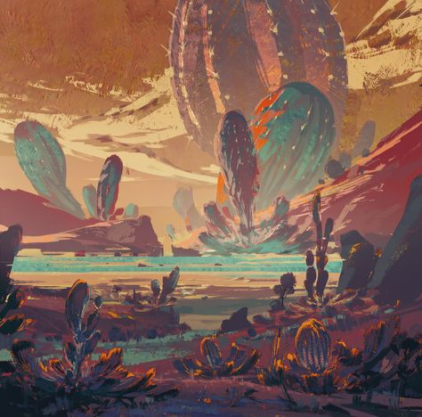

1️⃣ an artwork featuring an alien planet and desert, in the style of colorful brushwork, laurie greasley, sergey musin, dynamic and expressive animations, flowing brushwork, light amber and cyan, cloudcore --ar 59:58

2️⃣ this video art shows an alien landscape with several cactus in front, in the style of speedpainting, teal and amber, majestic ports, grandiose color schemes, hikecore, hard-edged painting, colorful washes --ar 59:58

3️⃣ an image of an alien landscape, in the style of colorful brushwork, ray tracing, energetic strokes, majestic ports, flat yet expressive, multilayered realism, light maroon and dark cyan --ar 59:58

4️⃣ an illustration depicting a city in a desert, in the style of ross tran, psychedelic color schemes, bulbous, lively nature scenes, elihu vedder, colorful animation stills, cyan and bronze --ar 59:58

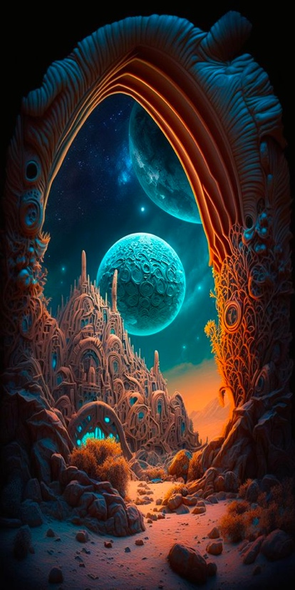

1️⃣ the scene of an alien planet opens up at an archway, in the style of intricate and bizarre illustrations, vivid dreamscapes, dark orange and turquoise, elaborate spacecrafts, the stars art group (xing xing), detailed world-building, dark cyan and silver --ar 1:2

2️⃣ an art illustration of a rocky planet and some space in front of it, in the style of dan mumford, jacek yerka, mixes realistic and fantastical elements, greg olsen, urban dreamscapes, turquoise and orange, ue5 --ar 1:2

3️⃣ an abstract image of a cave with a spaceship, in the style of dan mumford, spherical sculptures, hans zatzka, richly detailed genre paintings, saturno butto, dazzling cityscapes, sky-blue and orange --ar 1:2

4️⃣ the doorway through the galaxy, in the style of surrealistic fantasy landscapes, hyper-detailed illustrations, lunarpunk, cyan and bronze, playfully intricate, bryce 3d, grandeur of scale --ar 1:2

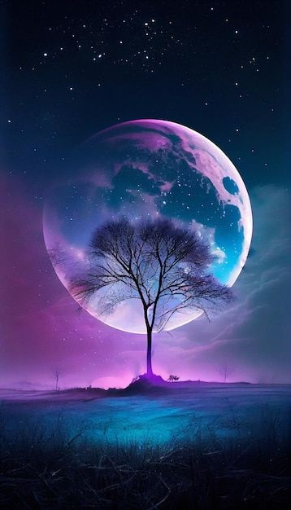

1️⃣ purple tree under the moon and dark sky, in the style of oliver wetter, paul lehr, saturno butto, light turquoise and light purple, cosmic, uhd image, multi-layered collage-like --ar 22:39

2️⃣ some dark blue and purple pictures of the lone forest tree up on the night sky, in the style of delicate fantasy worlds, saturno butto, wimmelbilder, dark pink and light cyan, igor zenin, digitally enhanced, l. birge harrison --ar 22:39

3️⃣ the moon is a huge purple colorful object, in the style of ethereal trees, photorealistic surrealism, dark pink and light aquamarine, wimmelbilder, colorful fantasy --ar 22:39

4️⃣ a moon with a purple cloud behind it, in the style of colorful fantasy, wimmelbilder, dreamlike, ethereal trees, uhd image, dark magenta and light aquamarine, double exposure --ar 22:39

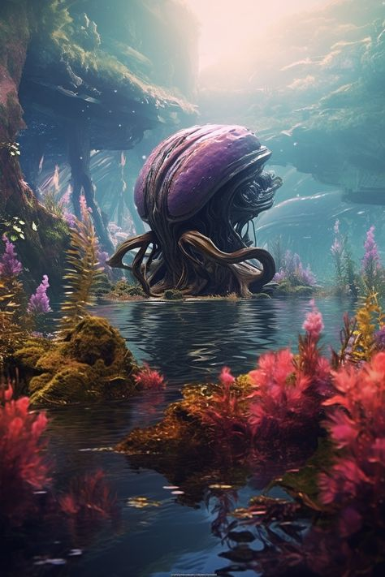

1️⃣ an octopus sitting in a water near plants and flowers, in the style of unreal engine 5, otherworldly illustrations, i can't believe how beautiful this is, futuristic landscapes, wandering eye, flowing textures, cabincore --ar 59:88

2️⃣ an alien creature in a flowing stream, in the style of beeple, floralpunk, xbox 360 graphics, mysterious backdrops, realistic marine paintings, bulbous, miniature dioramas --ar 59:88

3️⃣ a purple and pink octopus with pink flowers crated in a river with weeds, in the style of cryengine, futuristic landscapes, mysterious backdrops, zbrush, fictional landscapes, i can't believe how beautiful this is, futuristic art --ar 59:88

4️⃣ a pink octopus is submerged in the water, in the style of sci-fi landscapes, sketchfab, naturalistic depictions of flora and fauna, raphael lacoste, lush scenery, uhd image, environmental portraiture --ar 59:88

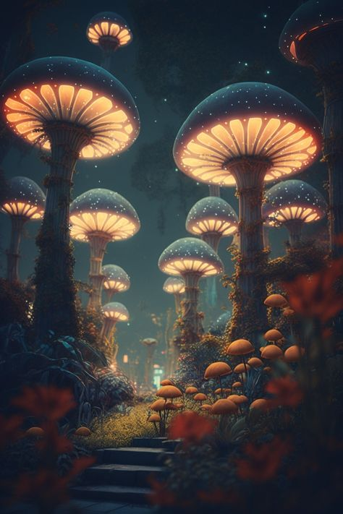

1️⃣ mushroom night, night mushrooms, mushrooms, fantasy hd, night, mushrooms, mushroom wall, mushrooms, mushrooms, in the style of cyberpunk futurism, light cyan and amber, i can't believe how beautiful this is, highly detailed foliage, nostalgic paintings, goblincore, afrofuturism --ar 59:88

2️⃣ mushrooms and trees at night in a fairytale, in the style of afrofuturism, hyper-realistic atmospheres --ar 59:88

3️⃣ fantasy garden 3d wallpaper, in the style of beeple, bioluminescence, jean-baptiste monge, neon lights, dark amber and sky-blue, angus mckie, art deco futurism --ar 59:88

4️⃣ some mushrooms in a field full of green, in the style of cyberpunk futurism, dark cyan and orange, raphael lacoste, intricate underwater worlds, the stars art group (xing xing), afrofuturism-inspired, baroque sci-fi --ar 59:88

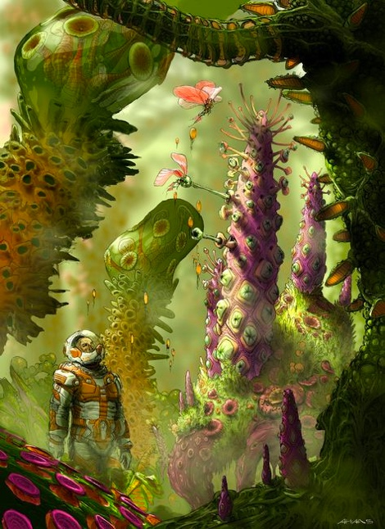

1️⃣ an original artwork featuring aliens and flowers in a sci fi world, in the style of transfixing marine scenes, gigantic scale, organic formations, flickr, orange and green --ar 59:81

2️⃣ science fiction illustration by liu duy, in the style of detailed flora and fauna, marine biology-inspired, spiky mounds, organic biomorphism, colorfield, pseudo-realistic, gigantic scale --ar 59:81

3️⃣ alien creature alien art spacecraft by paddy j aiken, in the style of naturalistic depictions of flora and fauna, victor nizovtsev, transfixing marine scenes, apocalypse landscape, dustin nguyen, , orange and green --ar 59:81

4️⃣ creature animation digital painting, in the style of elaborate spacecrafts, victor nizovtsev, detailed flora and fauna, robert mccall, surrealistic expressionism, xbox 360 graphics, aaron douglas --ar 59:81

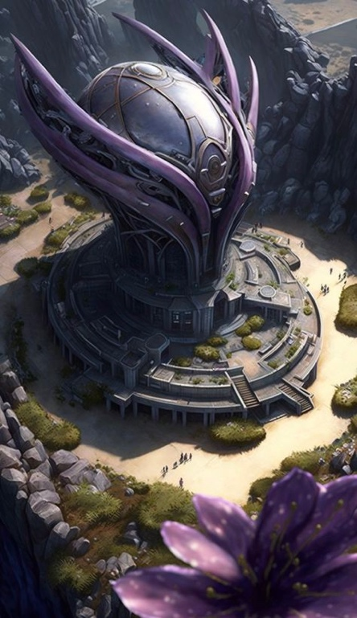

1️⃣ a building with a giant purple flower surrounded by rocks, in the style of futuristic landscapes, precise, detailed architecture paintings, bo chen, metallic rotation, grandiose ruins, aerial view, artgerm --ar 59:102

2️⃣ a very colorful scene with flowers and a futuristic building surrounded by rocks, in the style of purple and bronze, magali villeneuve, metallic rotation, kushan empire, high-angle, lorenzo costa the elder, neo-concrete --ar 59:102

3️⃣ the planet house with purple flowers on it, in the style of spatial concept art, grandeur of scale, interlacing artifacts, aerial photography, imposing monumentality, magewave --ar 59:102

4️⃣ an alien styled spacecraft surrounded by plants, in the style of grandiose ruins, purple and bronze, kushan empire, neo-concrete, imposing monumentality, piles/stacks, aerial photography --ar 59:102

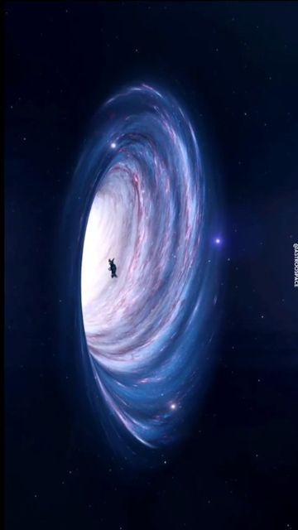

1️⃣ a black hole in the outer space with humans standing near it, in the style of i can't believe how beautiful this is, whirly --ar 9:16

2️⃣ aliens fleeing planet in black hole, in the style of animated gifs, i can't believe how beautiful this is, national geographic photo, prairiecore --ar 9:16

3️⃣ a black hole in between white stars with a swirl, in the style of beeple, i can't believe how beautiful this is, hayao miyazaki, grandeur of scale, depicts real life, surprisingly absurd, epic --ar 9:16

4️⃣ black holes: the ultimate black hole, in the style of animated gifs, national geographic photo, cosmic, nightcore, spirals, grandeur of scale --ar 9:16

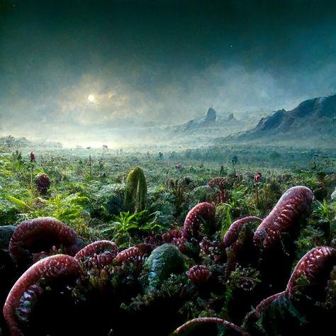

1️⃣ landscape shot of a venus flytrap, in the style of mystical creatures and landscapes, martin rak, chaotic environments, emek golan, photo-realistic landscapes, mysterious jungle, robert bissell

2️⃣ a desert scene with plants that look like aliens, in the style of phil koch, dark green and red, fantastic creatures, mushroomcore, i can't believe how beautiful this is, charles-francois daubigny, agfa vista

3️⃣ an abyss of strange plants, flowers and some lizards, in the style of apocalypse landscape, photo-realistic landscapes, i can't believe how beautiful this is, green and crimson, alien worlds, mushroomcore, joyful celebration of nature

4️⃣ an image of red and purple plants in a field, in the style of fantastical, otherworldly creatures, tropical landscapes, mushroomcore, national geographic photo, dark cyan and green, time-lapse photography, tabletop photography

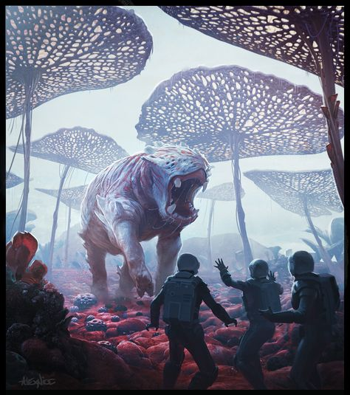

1️⃣ a giant monster wandering in the wild, where people stand, in the style of futuristic spacescapes, light red and dark indigo, mushroomcore, dinocore, poster art, detailed hunting scenes, human connections --ar 59:66

2️⃣ an illustration that shows military personnel with two aliens in the area, in the style of dino valls, dark white and light crimson, vibrant fantasy landscapes, mushroomcore, detailed crowd scenes, poster art, naturalistic depictions of flora and fauna --ar 59:66

3️⃣ an illustration with two men and a creature going off in the jungle, in the style of alien worlds, dark white and light crimson, detailed crowd scenes, dinocore, large-scale canvas, dusty piles, martin ansin --ar 59:66

4️⃣ an artistic version of something else, in the style of otherworldly scenes, fantastic creatures, poster art, detailed crowd scenes, redshift, spiky mounds, contrast of scale --ar 59:66

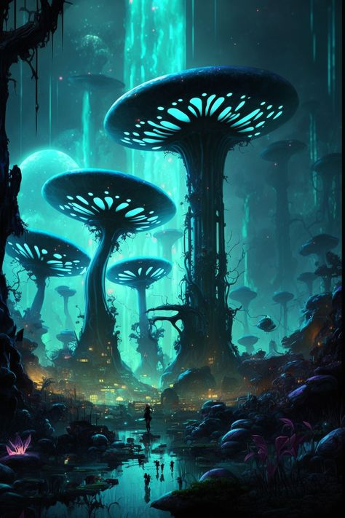

1️⃣ a dark fantasy landscape with lots of mushrooms and lots of people, in the style of dark cyan and light cyan, space art, columns and totems, i can't believe how beautiful this is, biomorphic, junglepunk, floating structures --ar 59:88

2️⃣ a blue color night scene with a man walking near some mushrooms, in the style of stephan martinière, dan mumford, dark cyan and green, i can't believe how beautiful this is, columns and totems, biomorphic, the stars art group (xing xing) --ar 59:88

3️⃣ sci fi fantasy landscape, in the style of mushroomcore, dark cyan, karol bak, paul ranson, systems art, algeapunk, józef mehoffer --ar 59:88

4️⃣ an image that looks like a landscape full of mushrooms, in the style of cyberpunk futurism, dark black and turquoise, columns and totems, i can't believe how beautiful this is, junglepunk, science fiction influences, caffenol developing --ar 59:88

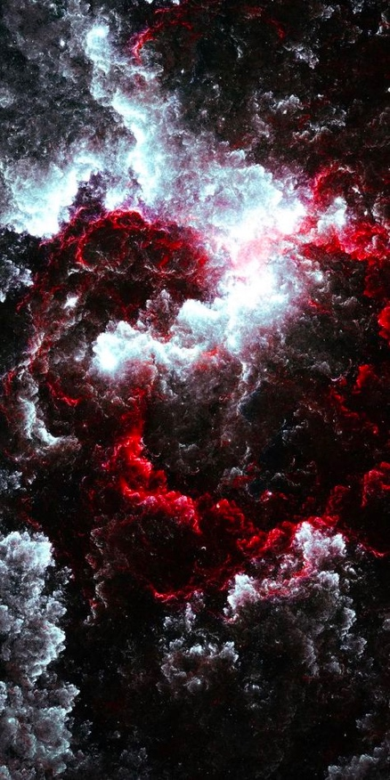

1️⃣ a large black and white cloud of light and red streaks, in the style of dark navy and dark crimson, fractalpunk, poured paint --ar 1:2

2️⃣ a black and white space scene with clouds and red, in the style of fluid abstractions, dark red and dark magenta, fractalpunk, tangible texture, aries moross, disintegrated, tony orrico --ar 1:2

3️⃣ a red color has been added to a cloud, in the style of dark matter art, textured splashes, dark white and dark purple, fractalpunk, celestialpunk, melting, caravaggesque --ar 1:2

4️⃣ a dark night sky with red and black clouds, in the style of fractalism, fluid organic forms, dark white and dark crimson, dark white and dark magenta, nanopunk, tactile texture, swirling vortexes --ar 1:2

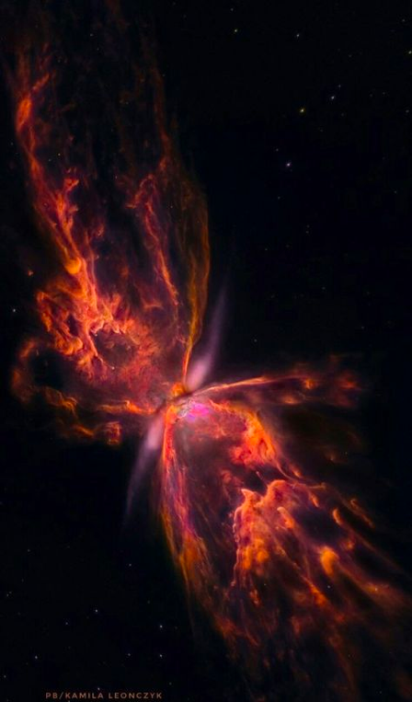

1️⃣ the image of this large butterfly is in a starry space, in the style of vivid energy explosions, dark orange and light magenta, tumblewave --ar 59:101

2️⃣ an orange and orange space nebula with a black smudge in front of it, in the style of dark white and magenta, depicts real life --ar 59:101

3️⃣ nasa's nebula, by david mccartney, in the style of polished metamorphosis, spacecore, dramatic splendor, uhd image, dark orange and pink, cinestill 50d, fairycore --ar 59:101

4️⃣ one of the nebulae is seen in different lights, in the style of surrealist metamorphosis, dark orange and pink, peter lippmann, black and white imagery, ultra hd, elaborate spacecrafts, vibrant hummingbirds --ar 59:101

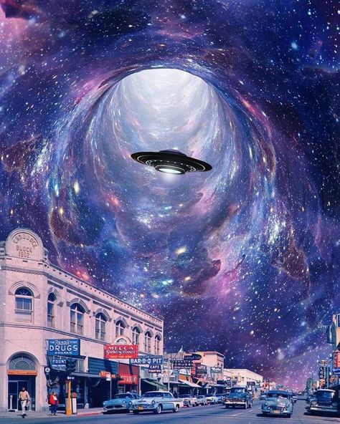

1️⃣ an alien flying around a city full of cars and building, in the style of mesmerizing optical illusions, iconic album covers, celestialpunk, hyperrealistic murals, interstellar nebulae, whirring contrivances, light sky-blue and dark purple --ar 59:74

2️⃣ there is an ufo flying through an empty parking lot in the background, in the style of larry carlson, east village art, interstellar nebulae, iconic album covers, casey weldon, the stars art group (xing xing), mike mayhew --ar 59:74

3️⃣ a bright star is seen in the sky with a tunnel, in the style of hyperrealistic murals, pop culture collages, elaborate spacecrafts, surreal cityscapes, swirling vortexes, east village art, alien worlds --ar 59:74

4️⃣ flies in a square space, in the style of fantastical otherworldly visions, iconic album covers, hyperrealistic street art, impressive skies, i can't believe how beautiful this is, alien worlds, passage --ar 59:74

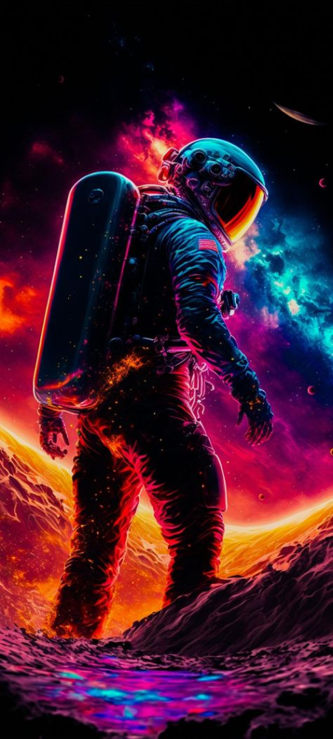

1️⃣ an astronaut on a planet with colorful sky and planets behind him, in the style of neon realism, hard edge painter, 3840x2160, dark crimson and red, realistic depictions --ar 59:131

2️⃣ the astronaut is standing in space and looking at planets, in the style of psychedelic hues, dark orange and magenta, celestialpunk, rtx on, movie poster, airbrush art, action paintings --ar 59:131

3️⃣ an astronaut is walking across the skyline with an alien in space, in the style of dan mumford, vibrant neo-traditional, gaston bussière, hyper-realistic details, colourful, 8k, saturno butto --ar 59:131

4️⃣ an astronaut standing near an earth in space, in the style of psychedelic neon, dan mumford, thiago valdi, poster art, gaston bussière, 4k, 1970–present --ar 59:131

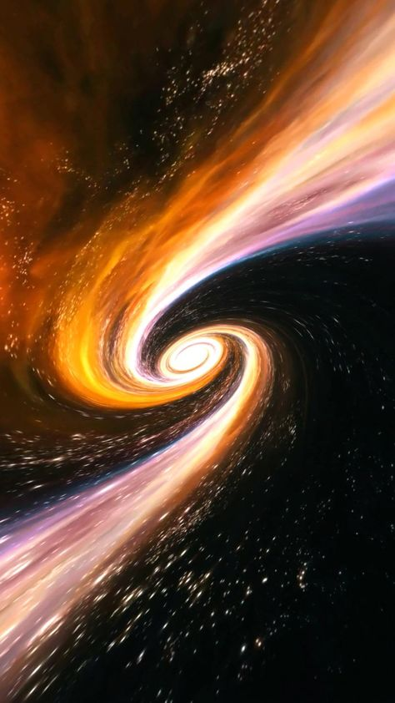

1️⃣ an image of a large spiral in space, in the style of dark gold and orange, swirling vortexes, aurorapunk, tumblewave, atmospheric skies, atmospheric installations, focus on atmospheric effects --ar 59:105

2️⃣ spiral wind in space, in the style of orange and black, atmospheric skies, dark sky-blue and gold, unreal engine 5, science academia, the stars art group (xing xing), dazecore --ar 59:105

3️⃣ a white and orange vortex in space galaxy stock videos & royaltyfree footage, in the style of emily carr, dark navy and dark gold, robert mccall, spirals, hyper-realistic sci-fi, yinka shonibare, light black and gold --ar 59:105

4️⃣ a spiral space animation, in the style of dark orange and light gold, dark sky-blue and light pink, alan bean, mysterious backdrops, emily carr, the stars art group (xing xing), swirling vortexes --ar 59:105

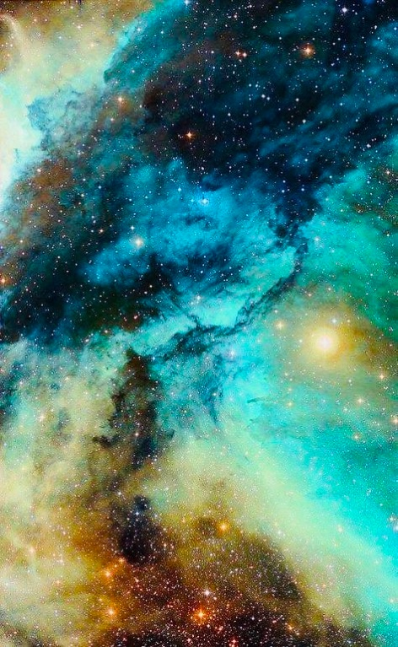

1️⃣ a colorful nebula with a star surrounding it, in the style of light turquoise and light yellow, light aquamarine and black, light turquoise and amber, light sky-blue and teal, lovecraftian, depicts real life, photo taken with provia --ar 59:96

2️⃣ a bright, colorful space wallpaper, in the style of light turquoise and dark amber, i can't believe how beautiful this is --ar 59:96

3️⃣ an image showing the nebulas in space, in the style of light turquoise and amber, light turquoise and black, purism, glorious, cosmic inspiration, light azure and amber, photo taken with provia --ar 59:96

4️⃣ an abstract background of space, with three stars and another nebula, in the style of light teal and light yellow, light black and sky-blue, light teal and dark sky-blue --ar 59:96

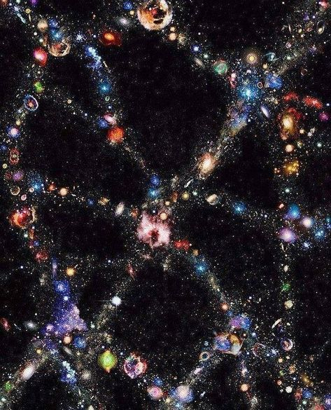

1️⃣ the image reveals the complex shapes of swirling clusters of stars, galaxies, and stars, in the style of visionary art, black background, focus on joints/connections, maximalism, high-keyed palette, infinity nets, dadaist photomontage --ar 59:73

2️⃣ galaxies are being found in many different parts of space, in the style of intricate collage, toyo ito, black background, philip taaffe, dusty piles, infinity nets, aerial view --ar 59:73

3️⃣ a large cluster of stars within an image, in the style of paula scher, dark and intricate, dark and chaotic, peter blume, infinity nets, vivid dreamscapes, use of precious materials --ar 59:73

4️⃣ a galaxy that can be seen clearly, in the style of intricate collage, infinity nets, grandeur of scale, science academia, carpetpunk, dusty piles, chiaroscuro mastery --ar 59:73

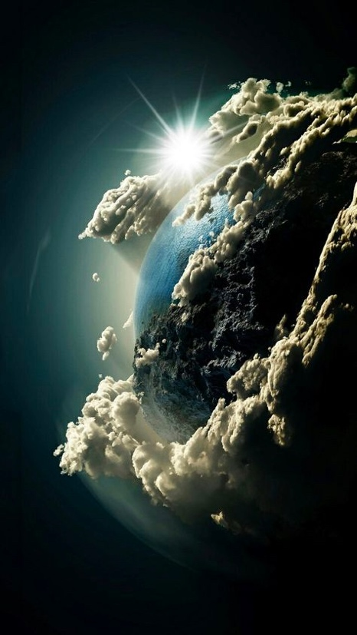

1️⃣ earth through the clouds wallpaper free, in the style of surrealistic metamodernism, photorealistic pastiche, thomas wrede, associated press photo, rough clusters, pictorial space, realistic portrayal of light and shadow --ar 59:105

2️⃣ the earth is hidden in the clouds, in the style of photorealistic fantasies, spacecore, flickr, pictorial space, contrasting light, ambitious --ar 59:105

3️⃣ wallpaper of the earth in white space over clouds, in the style of captivating, emotional imagery, light black and blue, firecore, dream-like imagery, fantastic imagery --ar 59:105

4️⃣ the earth from outer space in the sky above, in the style of dreamy symbolism, firecore, photo-realistic techniques, flickr, dramatic splendor, matte painting, rough clusters --ar 59:105

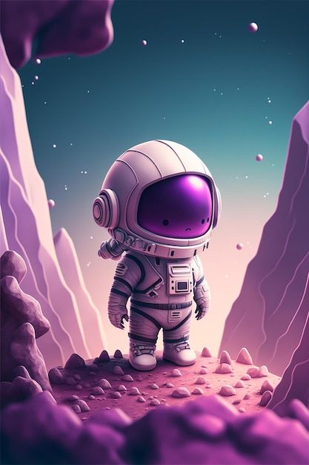

1️⃣ a little little astronaut standing next to some purple rocks, in the style of crisp neo-pop illustrations, realistic yet stylized, datamosh, flickr, hyper-detailed, charming characters, mono-ha --ar 2:3

2️⃣ a little chibi astronaut standing on top of a mountain, in the style of hyperrealistic illustrations, light magenta and purple, flickr, technology-based art, realistic yet stylized, cartoon-like characters, thick paint --ar 2:3

3️⃣ a little astronaut standing in front of a rock face, in the style of jeremiah ketner, realistic and hyper-detailed renderings, joel robison, light white and dark magenta, brian sum, angular, science-based --ar 2:3

4️⃣ animestyled astronaut with spacesuit on the ground, in the style of dark purple and light magenta, brian despain, jeremiah ketner, flickr, minimalistic landscapes, saturno butto, cartoon-like characters --ar 2:3

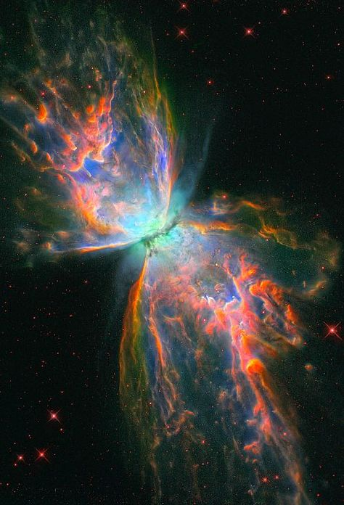

1️⃣ a large multi colored butterfly nebula, in the style of dark turquoise and light orange, whirring contrivances, light emerald and pink, science-based --ar 59:87

2️⃣ colorful butterfly the red ginkgo nebula, in the style of casts of spaces, sparklecore, science academia, #vfxfriday, interstellar nebulae, i can't believe how beautiful this is, teal and orange --ar 59:87

3️⃣ nasa's star nebula, in the style of psychedelic surrealism:, polished metamorphosis, crimson and aquamarine, dreamy symbolism, tumblewave, spacecore, gemstone --ar 59:87

4️⃣ eclipsing star rex with its eclipsing nebula, otto nasa image gallery 5, in the style of colorful explosions, teal and orange, angelic photograph, gossamer fabrics, multilayered surfaces, polished metamorphosis, paul barson --ar 59:87

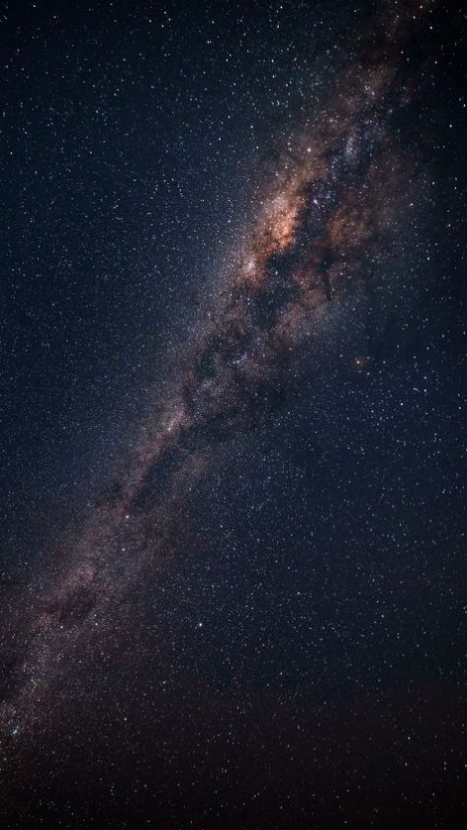

1️⃣ the milkyway in the night sky with stars in it, in the style of dark indigo and light brown, art of tonga, flickr, alessio albi, creative commons attribution, light pink and light black, symmetrical asymmetry --ar 59:105

2️⃣ the milky way at midnight, in the style of unconventional use of space, light pink and dark black, strong contrast between light and dark, art of tonga, creative commons attribution, dark indigo and light brown, high-angle --ar 59:105

3️⃣ the milkyway at night time, in the style of dark indigo and light brown, soft edges and atmospheric effects, sparklecore, symmetrical asymmetry, flickr, art of tonga, light pink and dark black --ar 59:105

4️⃣ dark night with milky way, in the style of creative commons attribution, art of tonga, unconventional use of space, dark indigo and light brown, high-angle, iso 200, ue5 --ar 59:105

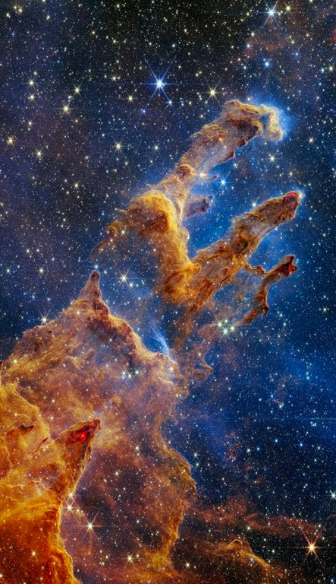

1️⃣ the nebula with the star, in the style of otherworldly landscapes, light amber and sky-blue, creased crinkled wrinkled, radiant clusters, flickr, otherworldly creatures, caninecore --ar 59:102

2️⃣ a nebula in space with stars and moons in view, in the style of creased crinkled wrinkled, light amber and sky-blue, elaborate, depicts real life --ar 59:102

3️⃣ a galaxy with a large amount of stars in the space, in the style of light amber and sky-blue, creased crinkled wrinkled, light crimson and indigo, caras ionut, romanticized depictions of wilderness, otherworldly creatures, 3840x2160 --ar 59:102

4️⃣ stars are visible in space, in the style of elaborate artistic environments, light orange and sky-blue, organic formations, hudson river school, archillect, laborwave, caras ionut --ar 59:102

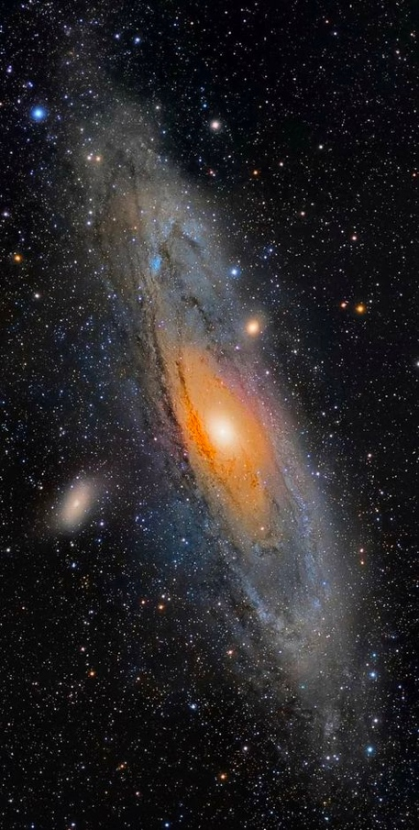

1️⃣ the spiral galaxy with many stars in the background, in the style of light orange and dark aquamarine, baroque-esque ornateness, mosscore, firecore, exacting precision, wildlife photography, polished concrete --ar 59:117

2️⃣ stargazing with galaxies stargazing with galaxies, in the style of light aquamarine and dark amber, grandeur of scale --ar 59:117

3️⃣ an image of a spiral galaxy in space, in the style of light orange and dark aquamarine, baroque-esque ornateness, light brown and light amber, light orange and light amber --ar 59:117

4️⃣ a galaxy with blue light and stars, in the style of light orange and light gray, baroque-esque ornateness, nikon af600, óscar domínguez, light black and amber, nature's wonder, rubén maya --ar 59:117

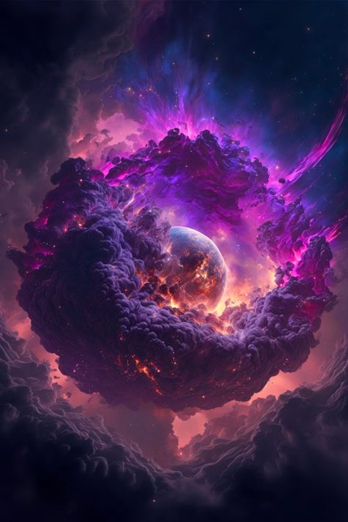

1️⃣ an image of a purple cloud surrounded by another image, in the style of space art, twisted futurism, wormcore, i can't believe how beautiful this is, vibrant illustrations, spherical sculptures, concept art --ar 59:88

2️⃣ a purple cloud covered in clouds, in the style of twisted futurism, space art, spherical sculptures, nightmarish illustrations, fairycore, spiral group, vibrant worlds --ar 59:88

3️⃣ the earth in a cloud, in the style of twisted futurism, dark purple and purple, mixes realistic and fantastical elements, anton fadeev, spirals, mysterious and dreamlike scenes, the stars art group (xing xing) --ar 59:88

4️⃣ sky of universe : how time flies, in the style of beeple, spiral vortex patterns, rhads, light gray and purple, spherical sculptures, psychedelic artwork, uhd image --ar 59:88

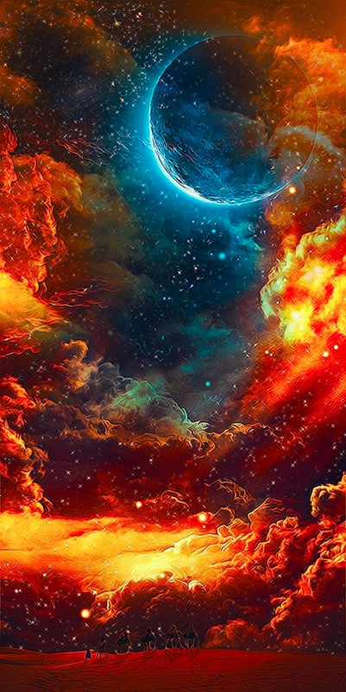

1️⃣ a space with an colorful image of clouds and stars on top, in the style of dark amber and red, spontaneous energy, sky-blue and gold, earthcore, precisionism influence, артур скижали-вейс, photobashing --ar 1:2

2️⃣ a cloudy space with a red moon and stars, in the style of colorful explosions, turquoise and amber, earthcore, swirling vortexes, flickr, realistic scenery, ambitious --ar 1:2

3️⃣ an image of a space, in the style of vibrant, high-energy imagery, precisionism influence, celestialpunk, harmonious chaos, caras ionut, red and amber, realistic blue skies --ar 1:2

4️⃣ a painting a star and moon and a space, in the style of colorful explosions, dark red and light aquamarine, impressive skies, swirling vortexes, flickr, vibrant, exaggerated scenes, dark orange and yellow --ar 1:2

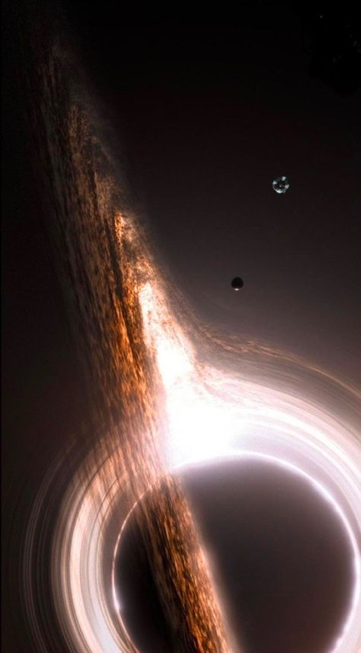

1️⃣ a black hole being surrounded by two other objects, in the style of mist, swirling vortexes, light brown and silver, blink-and-you-miss-it detail, pentax 645n, elaborate spacecrafts, impressive skies --ar 59:107

2️⃣ an artist's concept of the black holes, in the style of mist, toy camera effects, blink-and-you-miss-it detail, light silver and brown, impressive skies, elaborate spacecrafts, rubens --ar 59:107

3️⃣ an artist's image of a ring in a dark sky, in the style of tumblewave, blink-and-you-miss-it detail, light brown and light black, saturno butto, dynamic chaos, mist, mike campau --ar 59:107

4️⃣ ophiuchus supermassive black hole, july 2010, in the style of matte painting, mist, captivating documentary photos, distinctive noses, elaborate spacecrafts, tilt-shift photography, smokey background --ar 59:107

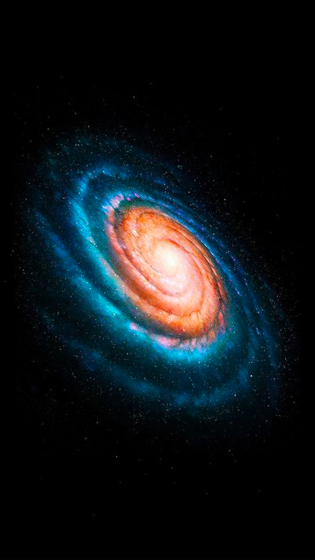

1️⃣ a picture of a spiral galaxy, and space in it, in the style of kadir nelson, spiritual symbolism, precisionist, i can't believe how beautiful this is, solapunk, perry rhodan, dreamy symbolism --ar 59:105

2️⃣ galaxy in space with blue and white spiral galaxy, in the style of light pink and dark orange, precisionist lines --ar 59:105

3️⃣ the spiral of galaxies in the sky, in the style of kadir nelson, spiritual symbolism, precisionist, solapunk, mystic symbolism, perry rhodan, carsten holler --ar 59:105

4️⃣ the galaxy has a blue ring on it framed prints custom, in the style of spiral vortex patterns, pictorial space --ar 59:105

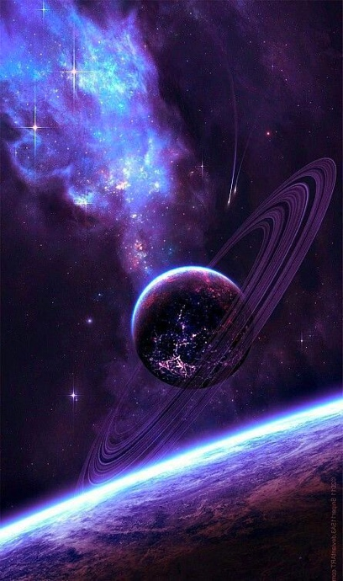

1️⃣ a space landscape featuring a blue saturn and a purple moon, in the style of i can't believe how beautiful this is, celestialpunk, pictorial space --ar 55:93

2️⃣ an image of outer space with planet and stars surrounding it, in the style of purple and blue, i can't believe how beautiful this is, celestialpunk, rim light, elaborate, transavanguardia, spatial --ar 55:93

3️⃣ saturn wallpaper desktop wallpaper black wallpaper on canvas saturn sane, in the style of purple and blue, pictorial space, i can't believe how beautiful this is, dreamlike perspectives, the stars art group (xing xing), light indigo and purple, luminous and dreamlike scenes --ar 55:93

4️⃣ space wallpaper wallpapers, in the style of purple and blue, realistic yet ethereal, saturno butto, jon foster, light black and purple, fantastic imagery, neo-op --ar 55:93

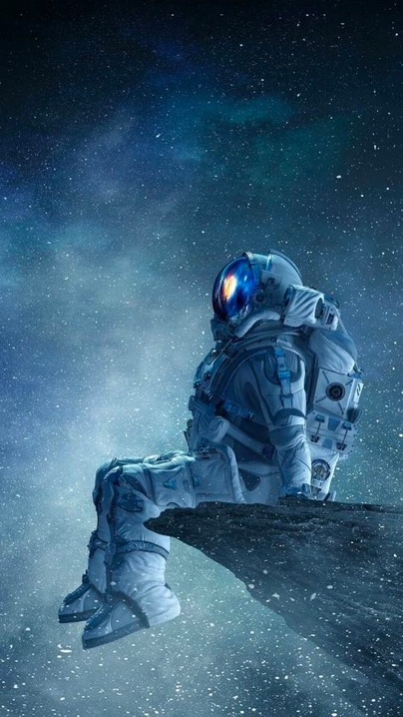

1️⃣ a spaceman sitting on a rock in space spacescape, in the style of gray and blue, frostpunk, movie still, relief, celebrity and pop culture references, science-based, associated press photo --ar 59:105

2️⃣ asteroid, spacecraft, astronaut sitting on rock, starry sky and blue horizons wallpaper, in the style of science-fiction dystopias, gray and blue, silver and blue, whistlerian, dark white and sky-blue --ar 59:105

3️⃣ astronaut sitting on rock near stars, in the style of science-fiction dystopias, gray and blue, frostpunk, 8k, movie poster, cabincore, associated press photo --ar 59:105

4️⃣ astronaut sitting on a cliff in the dark, in the style of science-fiction dystopias, silver and blue, frostpunk, associated press photo, mottled, casts of spaces, animated film pioneer --ar 59:105

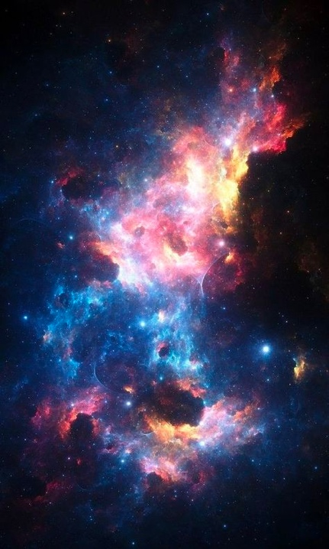

1️⃣ nebula and sky wallpaper, free wallpapers, in the style of dark turquoise and light crimson, dark navy and amber, radiant clusters, cosmic themes, light crimson and black, ue5 --ar 59:98

2️⃣ a galaxy in space with colored stars, in the style of dark turquoise and light crimson, ethereal qualities, glorious, firecore, dusty piles, light black and blue, 8k --ar 59:98

3️⃣ a view of the galaxy with nebula and different colors of stars, in the style of dark turquoise and dark crimson, ethereal symbolism, ue5, sparklecore, light black and blue, radiant colors, captivating light --ar 59:98

4️⃣ starfield | alien nebula galaxy, in the style of dreamy symbolism, crimson and azure, dark crimson and azure, light crimson and azure --ar 59:98

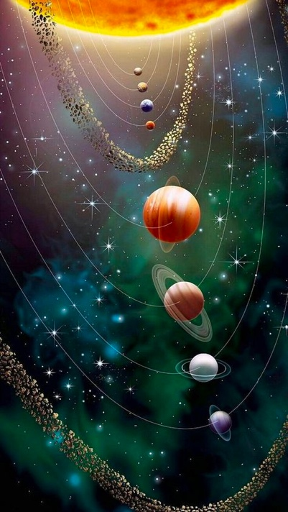

1️⃣ nasa outer space s solar system, in the style of whimsical absurdity, light emerald and dark crimson, y2k aesthetic, caravaggesque, light silver and gold, elaborate spacecrafts, pictorial space --ar 59:105

2️⃣ sun and planets in solar system, in the style of the stars art group (xing xing), light emerald and red, y2k aesthetic, light gold and purple, pictorial space, spiral group, elaborate spacecrafts --ar 59:105

3️⃣ planets in the solar system with the sun's orbit in the background, in the style of the stars art group (xing xing), light gold and green, y2k aesthetic, light aquamarine and red, dark purple and orange, spiral group, mysterious backdrops --ar 59:105

4️⃣ the moon, planets and sun are all shown outside planets, in the style of the stars art group (xing xing), light gold and green, y2k aesthetic, light aquamarine and maroon, spiral group, uhd image, pictorial space --ar 59:105

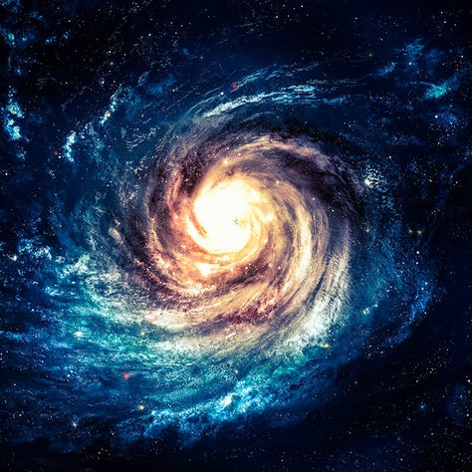

1️⃣ galaxy is the dark blue swirl with smudges of light, in the style of spiritual symbolism, hyper-realistic sci-fi, spiritual dimensions

2️⃣ the spiral spaceship galaxy, in the style of dreamy symbolism, expansive skies

3️⃣ an incredible blue space image featuring the star milky way, in the style of spiral vortex patterns, spiritual symbolism, light navy and amber, metaphysical realism, powerful symbolism, light sky-blue and dark crimson, mysterious symbolism

4️⃣ nebulosity, the spiral galaxy in space by peter stoessel, in the style of spiritual symbolism, mystical theme, mysterious space

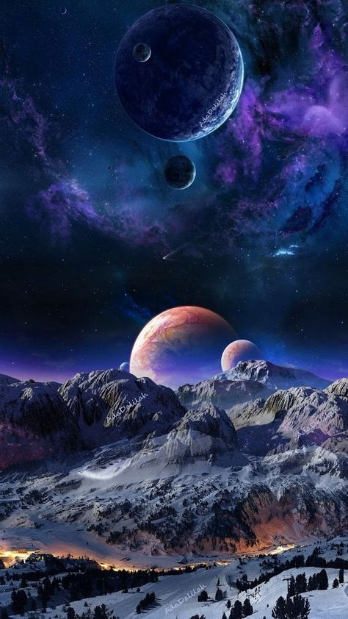

1️⃣ a landscape with the moon and a purple planet, in the style of mesmerizing colorscapes, elaborate spacecrafts --ar 59:105

2️⃣ planets in the snow landscape in colorful space, in the style of dark purple and light blue, dream-like imagery --ar 59:105

3️⃣ rahaa hd wallpaper galaxy art, in the style of realistic landscapes with soft edges, pictorial space, silver and purple, colorful fantasy realism, firecore, dreamlike realism, focus stacking --ar 59:105

4️⃣ an image of various planets that are all on top of some snow, in the style of purple and azure, romantic landscape vistas, celestialpunk, landscape realism, dreamlike realism, the stars art group (xing xing), i can't believe how beautiful this is --ar 59:105